Assignment 1: Automated Instance Management Using AWS Lambda and Boto3
Objective: In this assignment, you will gain hands-on experience with AWS Lambda and Boto3, Amazon's SDK for Python. You will create a Lambda function that will automatically manage EC2 instances based on their tags.
Task: You're tasked to automate the stopping and starting of EC2 instances based on tags. Specifically:
1. Setup:
- Create two EC2 instances.
- Tag one of them as `Auto-Stop` and the other as `Auto-Start`.

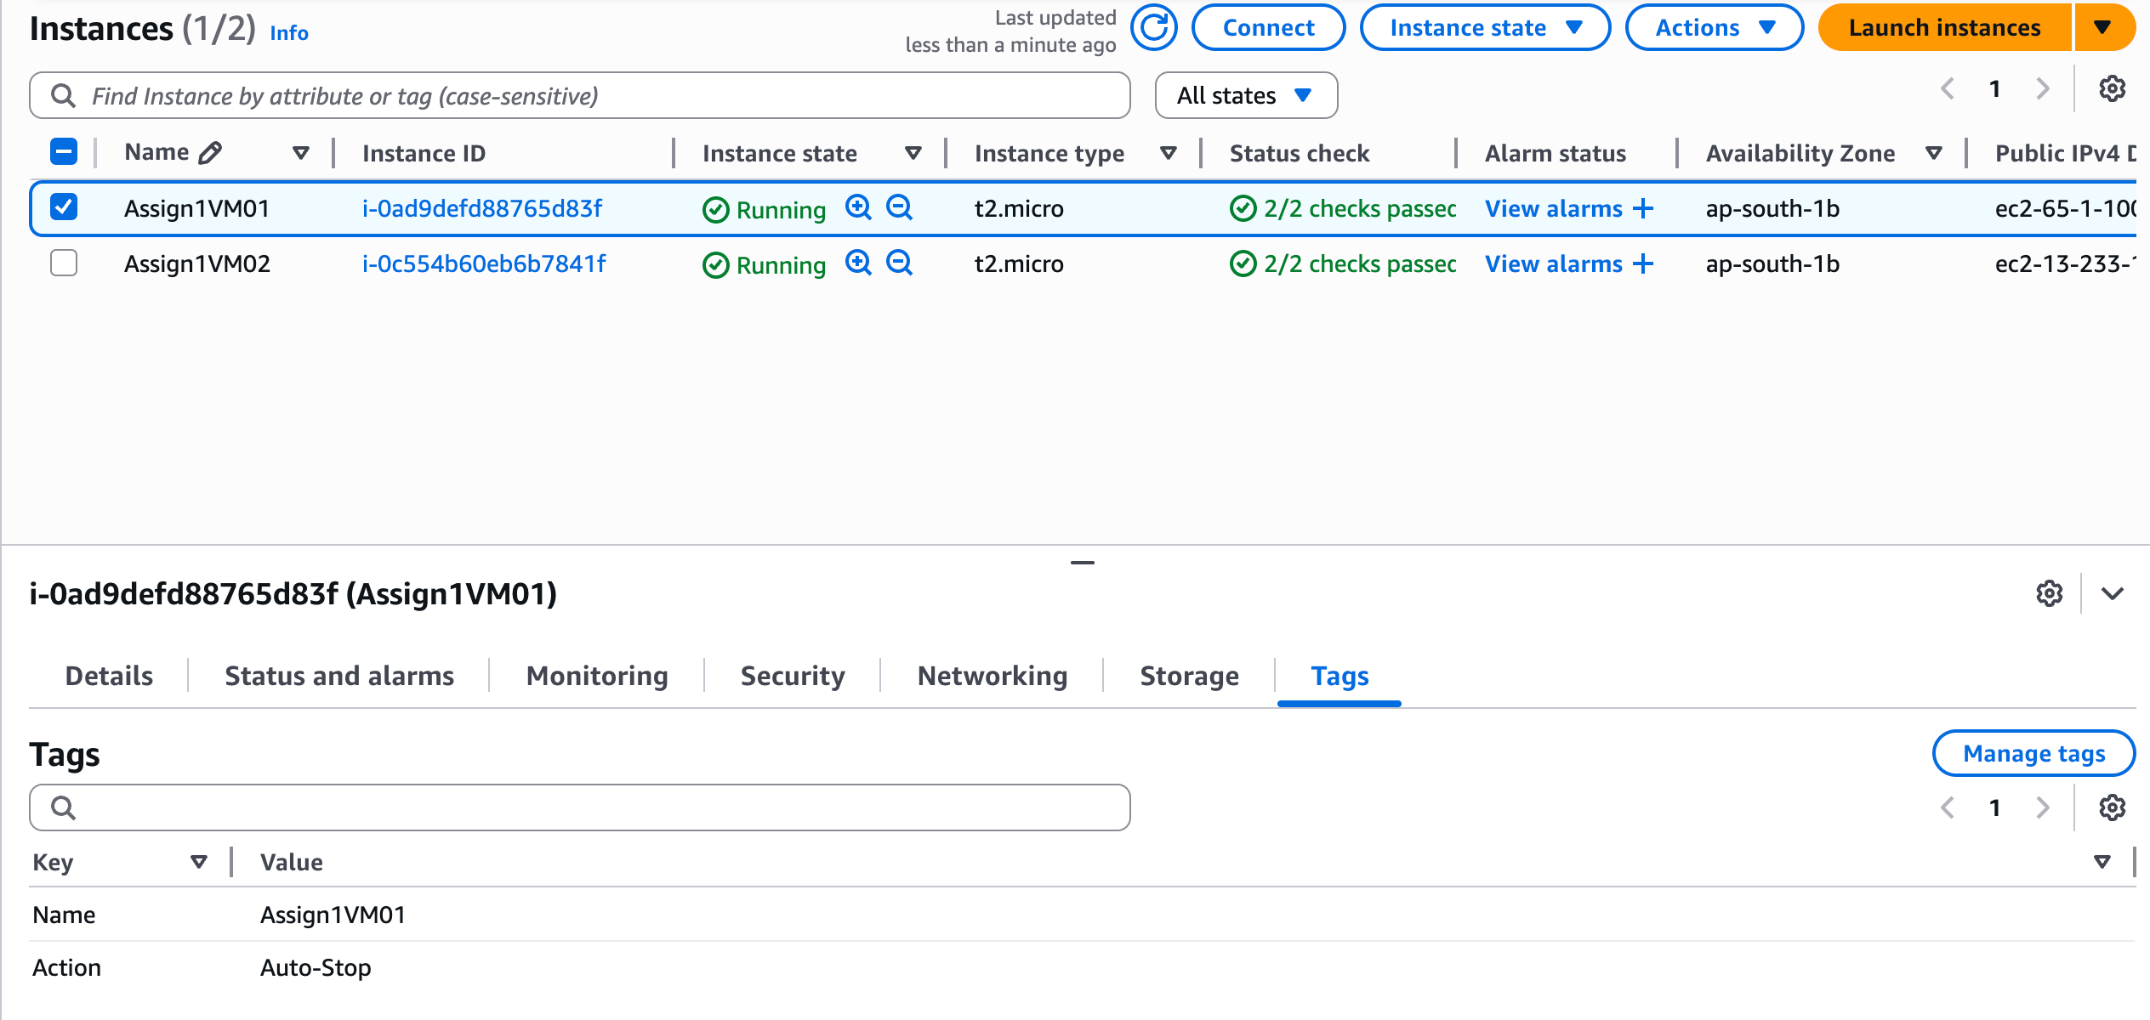
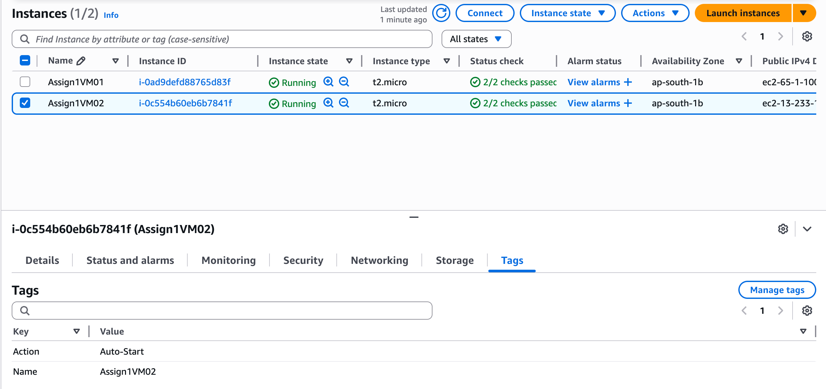

2. Lambda Function Creation:
- Set up an AWS Lambda function.
- Ensure that the Lambda function has the necessary IAM permissions to describe, stop, and start EC2 instances.
3. Coding:
- Using Boto3 in the Lambda function:
- Detect all EC2 instances with the `Auto-Stop` tag and stop them.
- Detect all EC2 instances with the `Auto-Start` tag and start them.
4. Testing:
- Manually invoke the Lambda function.
- Confirm that the instance tagged `Auto-Stop` stops and the one tagged `Auto-Start` starts.
Instructions:
1. EC2 Setup:
- Navigate to the EC2 dashboard and create two new t2.micro instances (or any other available free-tier type).
- Tag the first instance with a key `Action` and value `Auto-Stop`.
- Tag the second instance with a key `Action` and value `Auto-Start`.
2. Lambda IAM Role:
- In the IAM dashboard, create a new role for Lambda.
- Attach the `AmazonEC2FullAccess` policy to this role. (Note: In a real-world scenario, you would want to limit permissions for better security.)

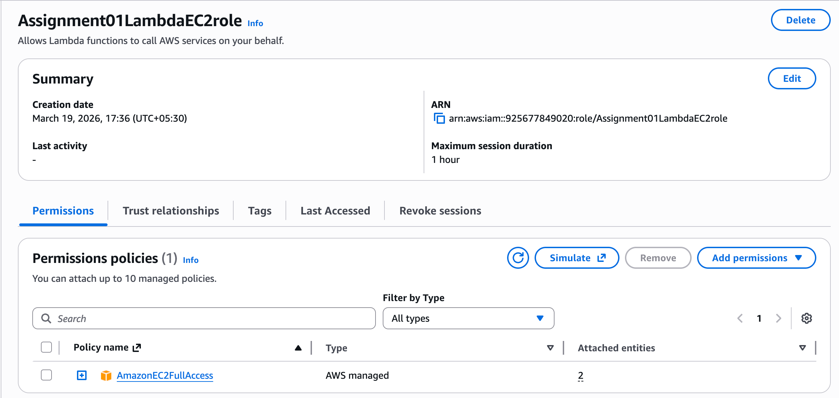

3. Lambda Function:
- Navigate to the Lambda dashboard and create a new function.
- Choose Python 3.x as the runtime.
- Assign the IAM role created in the previous step.
- Write the Boto3 Python script to:
1. Initialize a boto3 EC2 client.
2. Describe instances with `Auto-Stop` and `Auto-Start` tags.
3. Stop the `Auto-Stop` instances and start the `Auto-Start` instances.
4. Print instance IDs that were affected for logging purposes.
4. Manual Invocation:
- After saving your function, manually trigger it.
- Go to the EC2 dashboard and confirm that the instances' states have changed according to their tags.
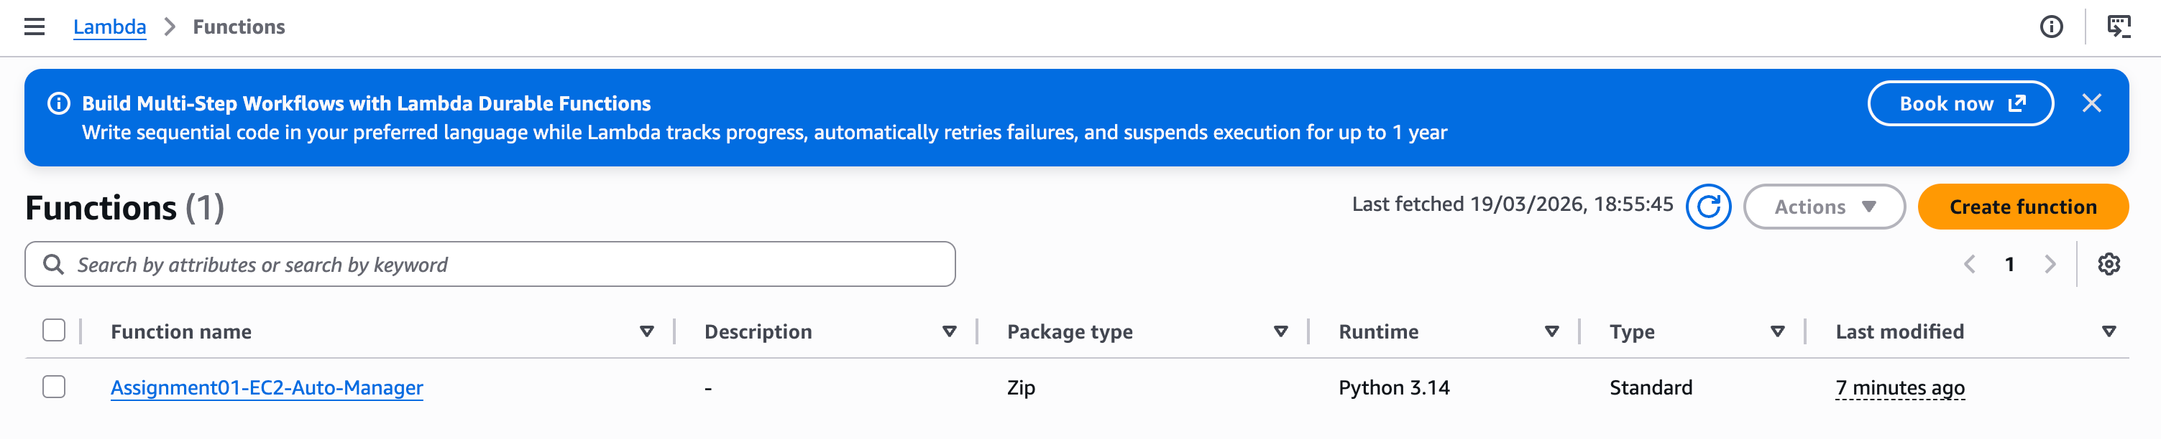
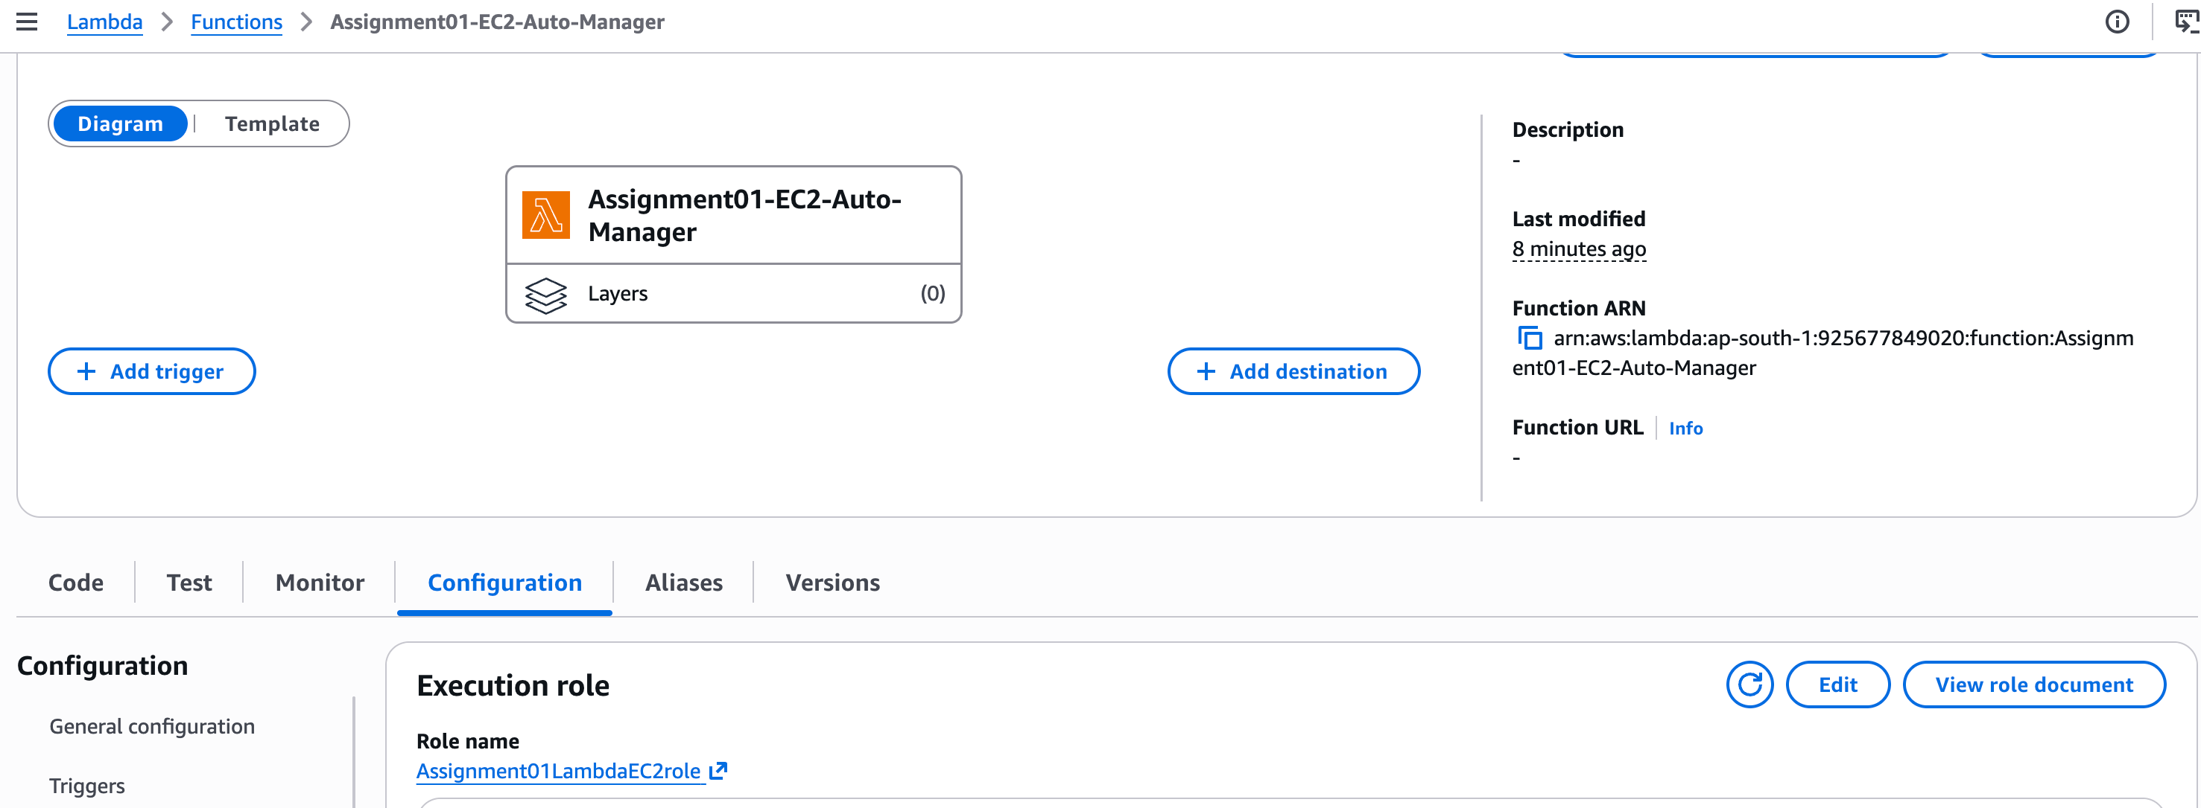

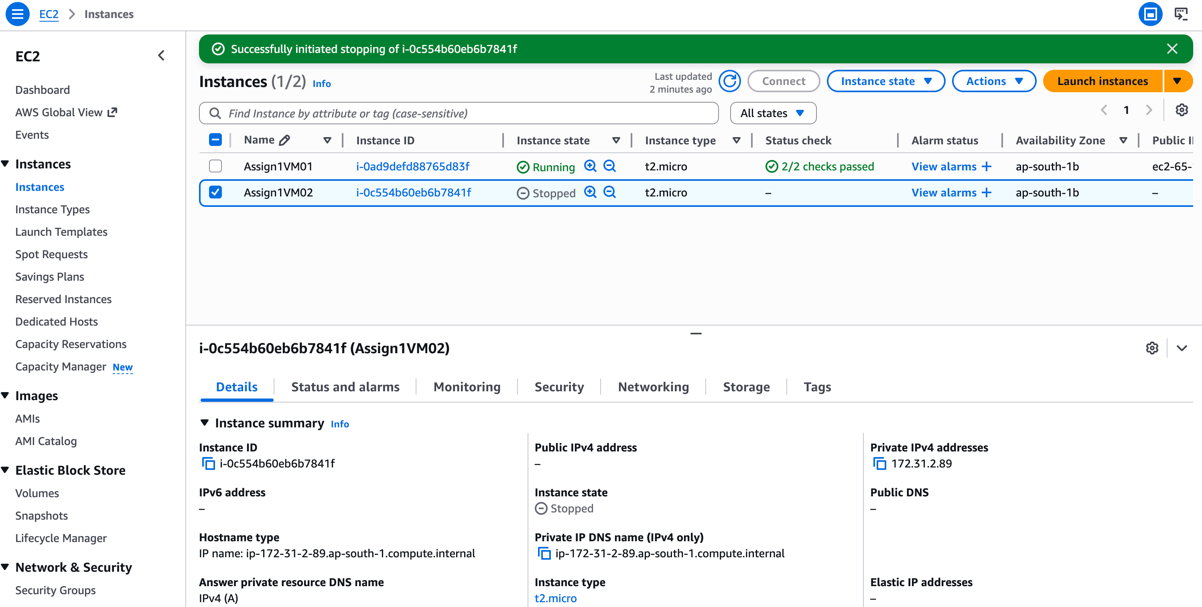

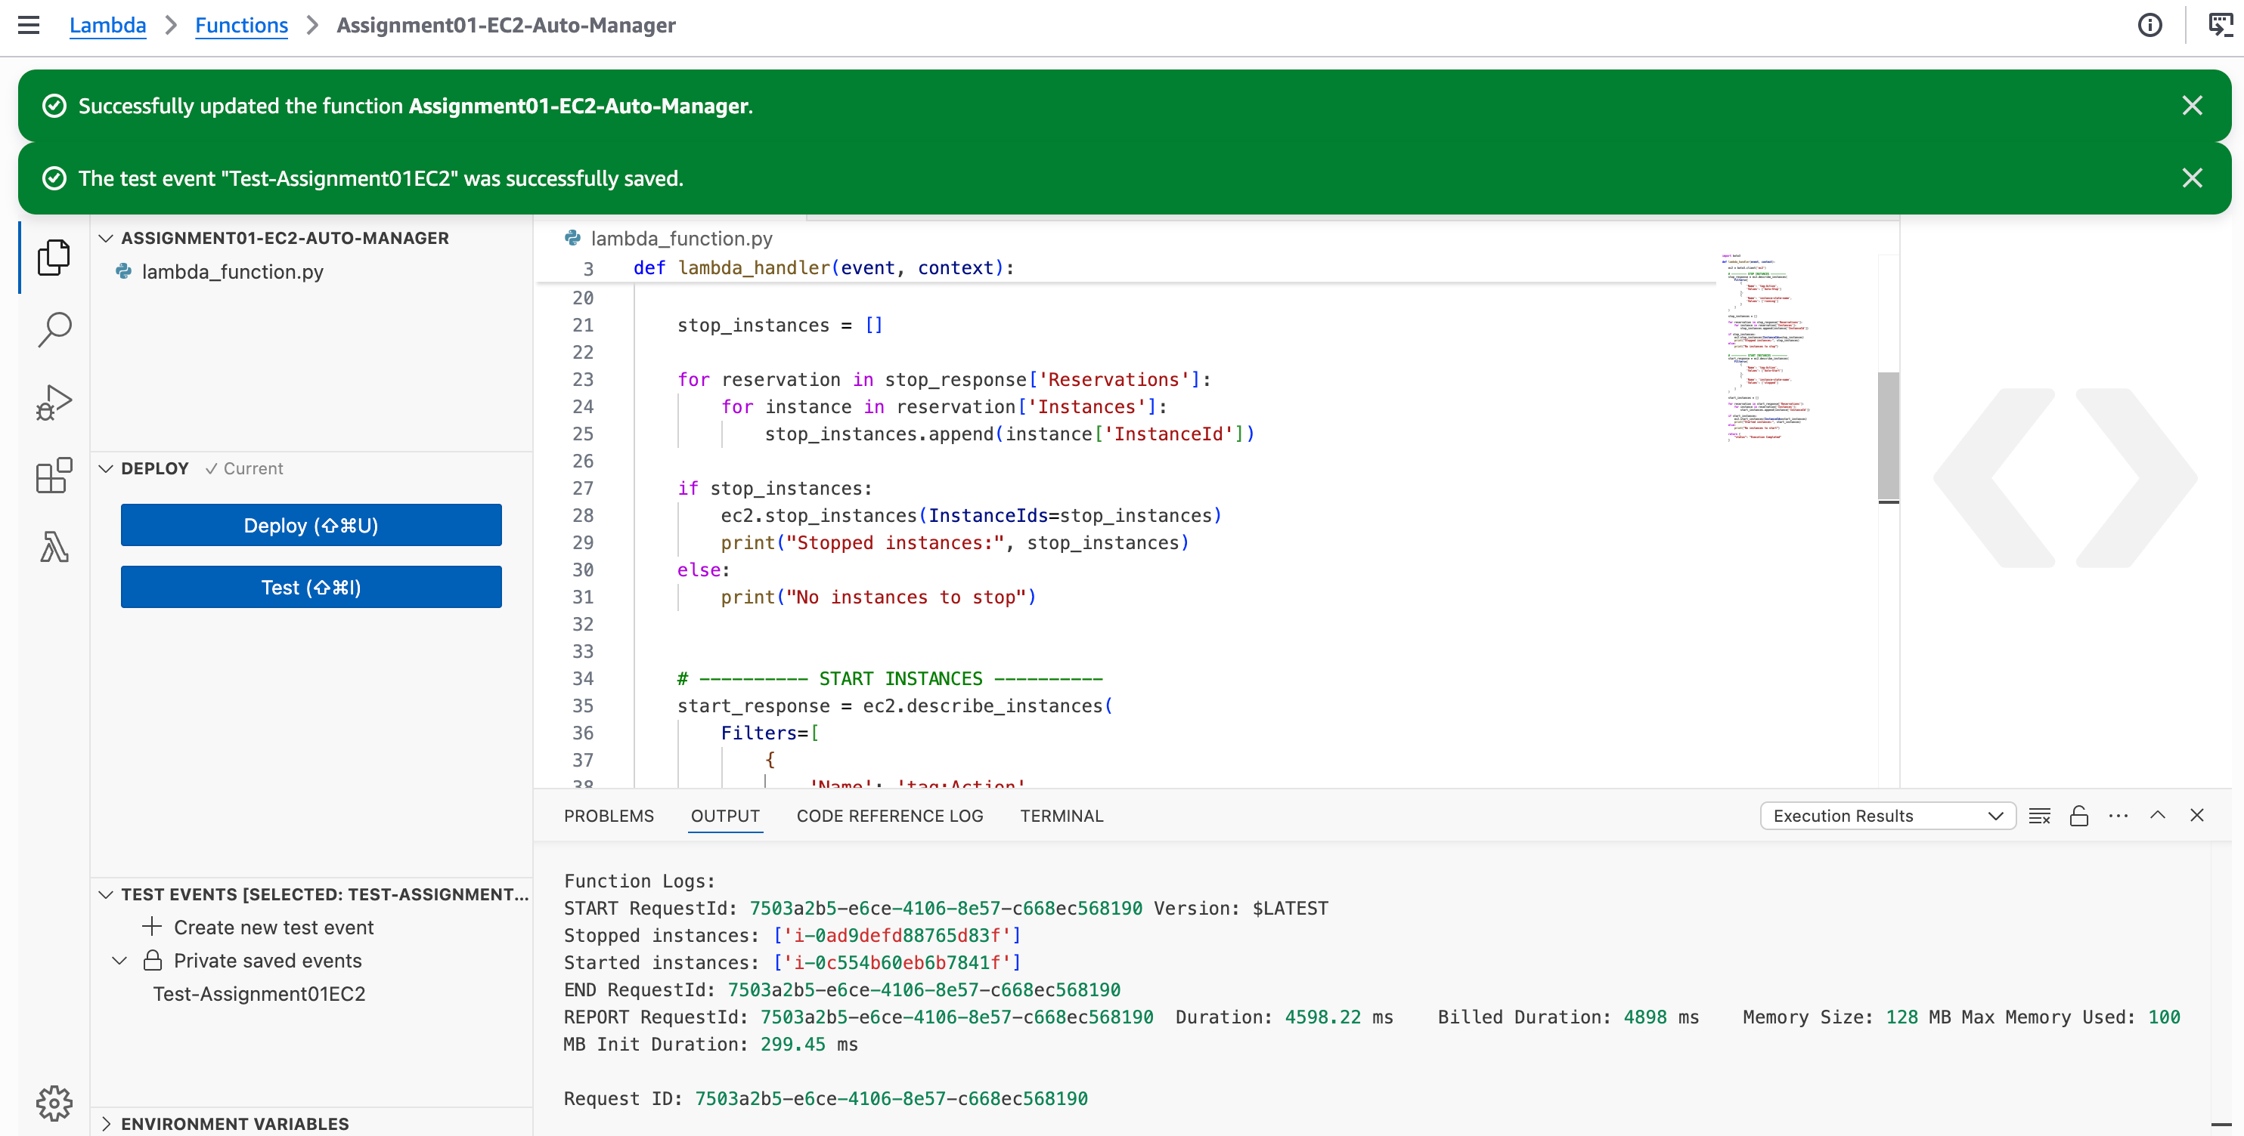

After execute the scripts. VM01 state has been changed from “Running” to “Stopped” and VM02 state has been changed from “Stopped” to “Running”

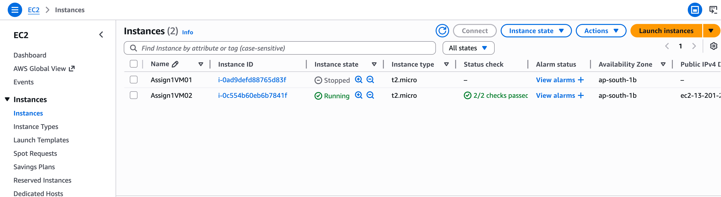

Lambda Scripts :

import boto3

def lambda_handler(event, context):

ec2 = boto3.client('ec2')

# ---------- STOP INSTANCES ----------
stop_response = ec2.describe_instances(
Filters=[
{
'Name': 'tag:Action',
'Values': ['Auto-Stop']
},
{
'Name': 'instance-state-name',
'Values': ['running']
}
]
)

stop_instances = []

for reservation in stop_response['Reservations']:
for instance in reservation['Instances']:
stop_instances.append(instance['InstanceId'])

if stop_instances:
ec2.stop_instances(InstanceIds=stop_instances)
print("Stopped instances:", stop_instances)
else:
print("No instances to stop")

# ---------- START INSTANCES ----------
start_response = ec2.describe_instances(
Filters=[
{
'Name': 'tag:Action',
'Values': ['Auto-Start']
},
{
'Name': 'instance-state-name',
'Values': ['stopped']
}
]
)

start_instances = []

for reservation in start_response['Reservations']:
for instance in reservation['Instances']:
start_instances.append(instance['InstanceId'])

if start_instances:
ec2.start_instances(InstanceIds=start_instances)
print("Started instances:", start_instances)
else:
print("No instances to start")

return {
"status": "Execution Completed"
}

